Recording of transaction
Answer the following

- State the three fundamental steps in the accounting process.
- Why is the evidence provided by source documents important to accounting?
3. Should a transaction be first recorded in a journal or ledger? Why?
4. Are debits or credits listed first in journal entries? Are debits or credits indented?
5. Why are some accounting systems called double accounting systems?
6. Give a specimen of an account. 2015-16 80 Accountancy
7. Why are the rules of debit and credit same for both liability and capital?
Select Right Answer:
1. Voucher is prepared for:
(i) Cash received and paid
(ii) Cash/Credit sales
(iii) Cash/Credit purchase
(iv) All of the above
2. Voucher is prepared from:
(i) Documentary evidence
(ii) Journal entry
(iii) Ledger account
(iv) All of the above
3. How many sides does an account have?
(i) Two (ii) Three (iii) one (iv) None of These
4. A purchase of machine for cash should be debited to: (i) Cash account
(ii) Machine account
(iii) Purchase account
(iv) None of these
5. Which of the following is correct?
(i) Liabilities = Assets + Capital
(ii) Assets = Liabilities – Capital
(iii) Capital = Assets – Liabilities
(iv) Capital = Assets + Liabilities.
6. Cash withdrawn by the Proprietor should be credited to: (i) Drawings account
(ii) Capital account
(iii) Profit and loss account
(iv) Cash account
7. Find the correct statement:
(i) Credit a decrease in assets
(ii) Credit the increase in expenses
(iii) Debit the increase in revenue
(iv) Credit the increase in capital
8. The book in which all accounts are maintained is known as: (i) Cash Book
(ii) Journal
(iii) Purchases Book
(iv) Ledger
9. Recording of transaction in the Journal is called:
(i) Casting (ii) Posting (iii) Journalising
10. Enter the following Transactions in the Journal of Mudit :
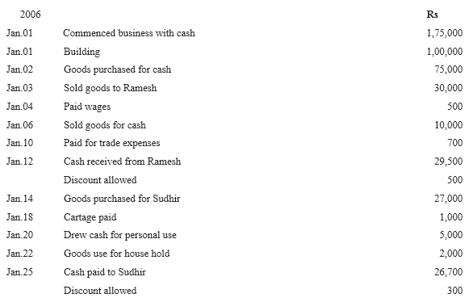

11. Soraj Mart furnishes the following information : Transactions during the month of April, 2014 are as under : Date Details 01.4.2014

Business started with cash Rs. 1,50,000.
01.4.2014 Goods purchased form Manisha Rs. 36,000.
01.4.2014 Stationery purchased for cash Rs. 2,200.
02.4.2014 Open a bank account with SBI for Rs. 35,000.
02.4.2014 Goods sold to Priya for Rs. 16,000.
03.4.2014 Received a cheque of Rs. 16,000 from Priya.
05.4.2014 Sold goods to Nidhi Rs. 14,000.
08.4.2014 Nidhi pays Rs. 14,000 cash.
10.4.2014 Purchased goods for Rs. 20,000 on credit from Ritu.
14.4.2014 Insurance paid by cheque Rs. 6,000.
18.4.2014 Paid rent Rs. 2,000.
20.4.2014 Goods costing Rs. 1,500 given as charity.
24.4.2014 Purchased office furniture for Rs. 11,200.
29.4.2014 Cash withdrawn for household purposes Rs. 5000.
30.4.2014 Interest received cash Rs.1,200.
30.4.2014 Cash sales Rs.2,300.
30.4.2014 Commission paid Rs. 3,000 by cehque.
30.4.2014 Telephone bill paid by cheque Rs. 2,000.
30.4.2014 Payment of salaries in cash Rs. 12,000.
Journalise the transactions.

